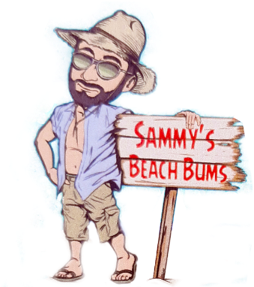
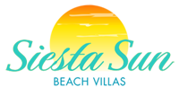

6424 Midnight Pass Rd.

Dear Guest,

We are excited to announce that we have partnered with Siesta Sun Beach Villas and Sammy’s Beach Bums Beach Rentals.

Owners of Midnight Cove II and guests renting through the Midnight Cove II/TSA/Prime Vacation rental program will now have access to Siesta Sun’s beach area with a qualifying rental from Sammy’s Beach Bums.

To reserve your beach chairs, Sammy’s Beach Bum Rentals can be contacted a few ways:
Website | www.sammysbeachbums.com
Telephone | 941-725-5527
On the Beach | Attendants are available Feb 1 – Aug 31 only
Minimum Requirements | REQUIRED PER UNIT  2 chairs and 1 umbrella - $35/day - $150/week  OPTIONAL  Additional chairs - $10/day
Small Cabanas | $35/day OR $185/week  Max of 5 cabanas allowed on Siesta Sun property at once. So please reserve ahead of time if you’re interested. Must be rented through Sammy’s
Prohibited Items | Chairs/loungers not rented through Sammy’s  Tents/Canopies
Allowed Items | Coolers

All of Siesta Suns rules and regulations MUST be complied with or you will be asked to leave and forfeit any refund on the chairs for the day and will not be allowed back on their beach. To access their beach area, use our private deeded access, then head south to their beach. DO NOT ENTER THEIR BEACH AREA THROUGH THEIR PROPERTY VIA MIDNIGHT PASS ROAD.

