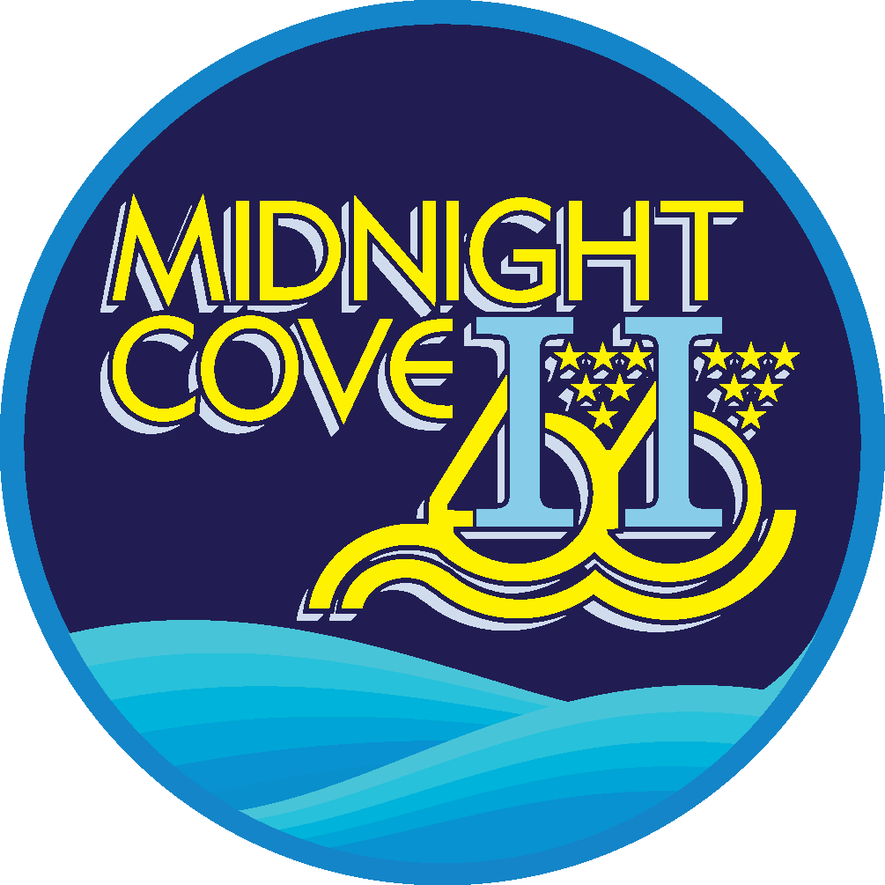

***______________________________________________***

**6327 Midnight Pass Rd.**

**Sarasota FL 34242**

**941.349.1163**

[**www.midnightcoveii.com**](http://www.midnightcoveii.com)

**MIDNIGHT COVE II**

**RULES AND REGULATIONS**

**FOR GUESTS**

**OCCUPANCY OF CONDOMINIUMS**

1. **REGISTRATION:** A Pre-Registration form will be sent to you prior to your arrival. It will require that you provide to us the following information:

* Full name of each occupant.
* Age of each occupant that will be residing in the unit that you have rented.
* The maximum occupancy for units is strictly enforced. Failure to comply may result in being asked to vacate the premises and forfeit all monies on the account.
* The MAXIMUM number of occupants is shown on your reservation and will be reviewed with you when you check in,

1. **BALCONY:** Guests shall not hang, dust, or clean garments, rugs, towels or any other items from the windows or from or over balconies or any of the facades of any building.
2. **GARBAGE:** Refuse, including garbage, cans, boxes, or any other similar items shall be placed only in containers or areas designated for such use. Refuse must not be left in the halls, staircases, landings, or other common areas. All refuse must be sealed in plastic trash bags and all boxes must be broken down.
3. **OBSTRUCTION:** NO obstruction of any common elements including the sidewalks, entrances, passages, vestibules, staircases, corridors, elevators, or halls.
4. **PLAY AREAS:** Public halls, elevators, stairways, and walkways cannot be used as a play area for children. Children shall not play on or about the common elements, except under reasonable supervision by a responsible adult.
5. **NOISE:** No person shall make or permit any noises that will disturb or annoy the occupants of any home or permit anything to be done that will interfere with the rights, comfort, or convenience of other persons, whether in their homes or on the common elements. Additionally, no person shall conduct or permit to be conducted vocal or instrumental instruction in any home.
6. **AGE RESTRICTIONS:** At least one person occupying the unit is at least 25 years or older. Guest will be asked to vacate immediately and no refunds will be given if Midnight Cove II

is made aware that this clause has been broken.

**VISITORS/GUESTS**

**GUESTS:** Only 2 guests are permitted per day.

Call or stop in to the office and let us know of your guests pending arrival. Or you may email us with this information at [mc2rentals@siestakey.com](mailto:mc2rentals@siestakey.com). When they arrive, have them check-in at the front office, and we will provide them with a parking pass.

**OVERNIGHT GUESTS:** If your guests will be staying overnight, their presence cannot result in you exceeding the occupancy limit of your unit.

**FIRE DEPARTMENT:** We would like to take this opportunity to remind you that the Sarasota Fire Department and/or the owner of your rental unit have determined the unit’s maximum occupancy. Failure to comply with these mandates may result in you being asked to vacate the premises and forfeit all monies on the account.

**LAUNDRY FACILITIES - ONSITE**

1. Laundry room is located at the front office.
2. Washers and dryers are coin operated.
3. Detergent is for sale at the office

**COMPLIMENTARY WI-FI**

1. Each individual unit has its own secured wireless internet. Logins and passwords are provided in your welcome packet.
2. Wi-fi is also provided at the pool area and the front porch of the office.

**PETS**

1. NO pets are allowed.

**PARKING**

**ALL RENTERS AND GUESTS MUST REGISTER EVERY VEHICLE**

**WITH THE ASSOCIATION OFFICE.**

1. RENTER: Rental quests are limited to a maximum of one automobile per unit and park in the assigned spot assigned for that unit. Additional guests may park in non- reserved spaces. Parking on driveways or lawn areas is prohibited at all times. Vehicles must display a parking pass when parked on property. These are available in the Association Office.
2. All rental guests and visitors must stop at the office, register their vehicles, and receive a parking pass. Midnight Cove II is a tow away property and all non- registered vehicles are subject to being towed at the owner’s expense.
3. TRAILERS: No trailers of any sort are permitted on the property except on a temporary basis not to exceed 24 hours. This includes boat trailers, u-haul trailers, mobile home trailers or any other type of trailer. Prior approval must be given in advance by the Association Office.
4. No recreational Vehicles, Golf Carts (unless the golf cart is your one vehicle), Motorcycles, Scooters, Electric Bicycles, Commercial Vehicles or trailers of any kind are permitted.

* All vehicles on the premises must be in operable condition. No storage of covered or uncovered vehicles shall be permitted in guest parking spaces.
* Vehicles on the property may not be occupied as living quarters at any time.
* Vehicles violating any of these Rules and Regulations will be towed at their guest expense.
* Vehicles are not permitted on the property without current license plate and registration.
* No skateboarding or roller blading on the property.

1. **SPEED:** Vehicles must maintain a speed limit of 10 m.p.h. or less.
2. **NO PARKING:** No parking on grass or any other prohibited areas.
3. **REPAIRS:** Motor repair or other repair work to an automobile is PROHIBITED as well as storage of any household articles, furnishings, or furniture within the parking space or outside the unit or limited common elements.

**BIKE RACKS**

Bike racks are available throughout the property for guest use. Guests need to supply their own lock. Bikes are NOT permitted to be locked up to anything on property other than the bike rack. DO NOT lock bikes to trees, carports, stairwells or leave them outside of any building.

**SWIMMING POOL**

**POOL RULES ARE POSTED IN THE POOL AREA**

**VIOLATORS OF THE RULES WILL BE ASKED TO LEAVE THE SWIMMING POOL.**

1. The pool is open from 8:00 a.m. to 10:00 p.m., year-round.
2. No children under the age of 12 may be in or around the pool area unless accompanied by a responsible adult.
3. No styrofoam materials, floats, rafts, noodles, or any other floatation devices are permitted in the pool at any time.
4. No glass in pool area FL Statue 514 & FAC64E-9.
5. No pets are permitted in the pool area at any time.
6. No running or jumping
7. Proper swim wear required in pool
8. No horseplay and no throwing or tossing of balls, frisbees or toys of any kind.
9. The playing of loud radios, iPad, cell phones or any entertainment device is not permitted so it does not disturb owners and guests.
10. No hanging, standing or removing the pool rope
11. Special swim apparel must be worn by children 3 & younger when in pool
12. Swimming in the lagoon is prohibited.

**TENNIS COURTS**

1. **RULES:** Guests and tenants are subject to the rules posted at the courts. Violators of these rules will be asked to leave the courts by the Association Management. Proper tennis attire, including tennis shoes and tennis shirts must be worn on the courts.
2. **ROUND ROBIN:** Play is every Monday, Wednesday, and Friday from 9:00 a.m. to 11:00 a.m. between October 1 and February 28 and from 8:00 a.m. to 10:00 a.m. at all other times of the year. All owners, tenants, and guests may participate in round robin play.
3. **PICKLEBALL:** TENNIS COURTS are reserved for PICKLEBALL play every Tuesday, Thursday, and Saturday from 9:00 am – 11:00 am between October 1, and February 28, and from 8:00 am to 10:00 am at all other times of the year.
4. **PROHIBITED:** No chairs or toys are allowed on the courts. Courts should be left free from debris.

**COMMON AREAS**

1. No skateboards or rollerblades are allowed on the property.
2. Do not feed the birds or any wildlife.
3. NO use of gas-fired grills, open fires, charcoal grills, hibachis or other similar devices used for cooking, heating or other purposes on any balcony or under any overhanging portions such as landings or first floor entrances. Midnight Cove II Association, in compliance with the National Fire Protection Act, Section 1:10.11.7,

**GRILLING**

1. Grilling is only permitted at the three designated areas between 8:00 am and 10:00 pm.

Adjacent to the tennis courts near the maintenance shop

Northside of building 9

In front of building 1 to the west side

1. Grills are not assigned or dedicated to any one individual or family. Grill needs to be shared by all guests.

**SMOKING**

Smoking is allowed ONLY in the Car Wash Café area which is located by the picnic/grilling area. Please use the provided cigarette bin for disposal. Smoking is PROHIBITED inside any buildings, on walkways and tennis courts, pool, or grilling areas, inside units, on balconies, lanais, and adjacent walkways.

**TURTLE SEASON**

Turtle season begins May 1 and ends October 31. Please support efforts towards being a turtle-friendly guest by complying with County & State Law Ordinance #97-082.

Fill in holes that may entrap hatchlings on their way to the water and knock down sandcastles.

Never approach nesting turtles or pick up hatchlings. If you find an unmarked nets, contact a staff member and we will contact the county.

Only use flashlights to enter and exit the beach.

Do not disturb turtle nests IN ANY WAY. You will be prosecuted

**FISHING**

Fishing is allowed at P1 and P14 dockage only. Fishing is not allowed on any other docks or in the boat basin area.

**FREQUENTLY USED TELEPHONE NUMBERS**

MIDNIGHT COVE II ASSOCIATION OFFICE……………………..941-349-1163

Emergency ………………………………………………………………911